Science 9 Earth’s Energy Sources

Earth receives energy from 3 main sources:
- Solar radiation, including visible light, infrared radiation, and other types of radiation, comes from the Sun
- Residual thermal energy from when Earth was formed (Big Bang) is slowly released.
- Decay of underground radioactive elements produces energy.
This energy is cycled around the Earth, affecting our weather, nutrient cycles and water cycle.

A. Radiation
Radiation is the transfer of heat by electromagnetic waves.
- EMR that reaches Earth is absorbed by molecules in the atmosphere, water, and land, which convert the EMR into thermal energy.
  - 49% is absorbed by the land and oceans
  - 42% is absorbed, reflected, or scattered by the atmosphere
  - 9% is reflected by Earth’s surface
- Radiation that is absorbed by the land and water is emitted as infrared (heat) radiation, which is absorbed by the atmosphere.

B. Conduction
Conduction describes heat transfer that occurs when faster moving particles collide with slower moving particles. During conduction, heat is transferred from matter with a higher temperature and greater kinetic energy to matter with a lower temperature and less kinetic energy.
- Energetic molecules collide with other molecules and transfer their energy.
- Energetic molecules on the surface of the land and water, which have absorbed radiant energy, collide with gas molecules in the atmosphere and transfer energy to them.
- Gas molecules that are warmer than the surrounding molecules transfer thermal energy to these less energetic molecules.
- Conduction is most effective at transferring energy in dense substances (solids and liquids) since the molecules in these substances are closer together.
- Different materials conduct heat at different rates. For example, Metals are good thermal conductors while wood and air are not.

C. Convection
Convection is the transfer of heat within a fluid, where the fluid actually moves from one place to another. Unlike conduction, convection transfers matter as well as heat.
- As air near Earth’s surface warms due to conduction, it becomes less dense and rises.
- Rising warm air is replaced by descending cool, dense air, thus generating convection currents. These convection currents affect Earth’s weather, the cycling of nutrients and matter, as well our water cycle.
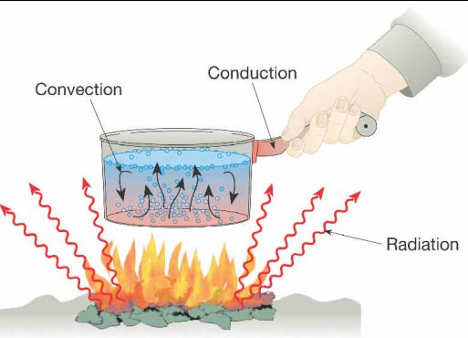
Convection is a major factor in weather. The sun heats the earth’s surface, then, when cooler air comes into contact with it, the air warms and rises, creating an upward current in the atmosphere. That current can result in wind, clouds, or other weather.

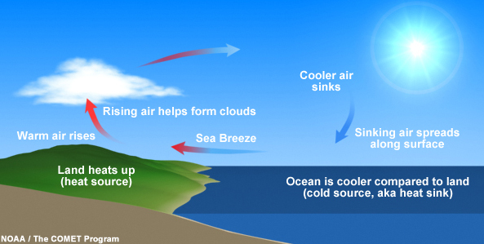

You may enjoy the gentle breezes at seashore, but you may not know that these breezes are formed by convection of air currents. Recall that water has a higher specific heat capacity than land, therefore the land has a higher temperature than the sea as the sun shines over them in the daytime. The air above the land warms up and rises and the cool air over the sea moves in to take its place, resulting in the sea breeze in the daytime. At night, as the sea maintains its temperature better and is warmer than the land, the roles of land and sea reverse and convection of air results in the land breeze.

Sea Breeze
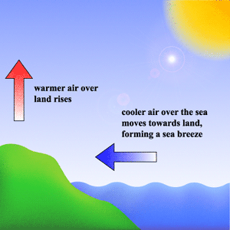
Land Breeze
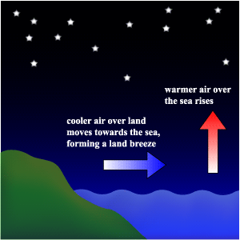

Practice
- Label the arrows on the diagram to describe the processes of energy transfer. Use the following terms: conduction, convection, radiation.
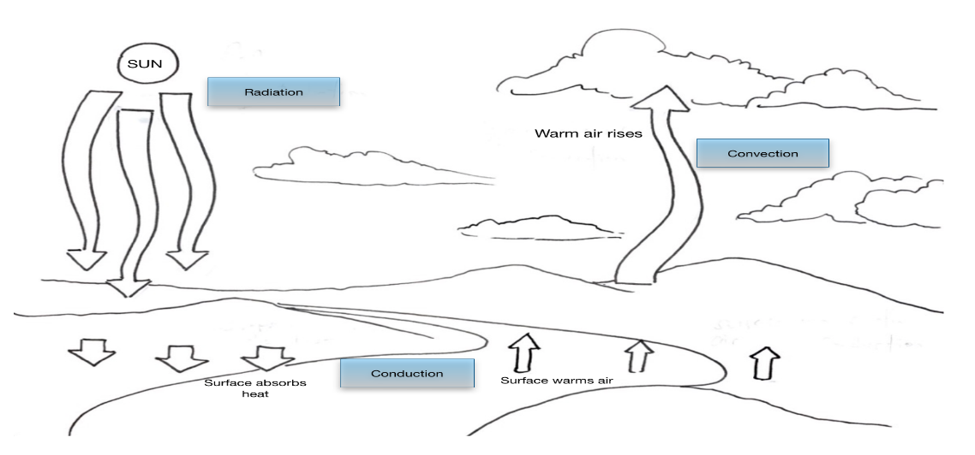

- Which mechanism (convection, conduction, and/or radiation) best describe the following
energy transfers?

- a warm breeze blowing inland _______________________
- a damp cloth cooling your forehead ___________________
- a spoon warming in a coffee cup _____________________
- a microwave heating a bowl of soup __________________
- a boy warming his hands by a fire ____________________

- As the temperature of an object decreases, the kinetic energy of the object ___________.

- Which type of thermal energy accounts for the movement of clouds? ________________.

- What causes an offshore breeze to develop?

_______________________________________________________________________

- Approximately 58% of incoming solar radiation reaches Earth’s surface. Nearly 48% of the
incoming radiation gets radiated back into space. What happens to the remaining incoming radiation?
________________________________________________________________________
________________________________________________________________________

- Describe the process of air movement for an onshore breeze.
________________________________________________________________________
________________________________________________________________________

(b) Why do onshore breezes usually occur at night?
________________________________________________________________________
- Compare a boiling hot cup of tea to an iceberg floating in the ocean.

- Which has greater thermal energy? ___________________________________________
- Which has particles with the highest average kinetic energy? ______________________
- Which has more potential energy? ___________________________________________
- If placed together, would heat flow from the tea to the iceberg or from the iceberg to the tea? __________________________________________________________________
- Consider a snowy hill, Earth’s atmosphere and a cornfield. Which absorbs the most solar energy? Why?

________________________________________________________________________
________________________________________________________________________

- Explain why the hot water rises in this diagram. Explain why the cool water sinks. You should be using words like density, molecules, heat, movement… 